XHTML & Web Design
Report Workbook


Assignment Assessment Overview

Each Group should complete the following in relation to the Group work process and submit as part of your project.

Group Report and Logbook | 20%
Online Logbook – There should be at least one progress-report entry posted each week by each Group | 3%
Template 1 – Roles & Responsibilities | See below
Template 2 – Understanding the Problem | 1%
Template 3 – Exploring Ideas | 2%
Template 4 – Group Action Plan | 2%
Template 5 – Individual Action Plan | 3%
Template 6 – Individual Reflection | 3%
Template 7 – Bibliography | 1%
Template 8 – Peer Review | 5%

Template 1 Roles & Responsibilities

Roles & Responsabilities


In order for the group to work effectively it is necessary for members to take responsibility for specific tasks. Assign a group member to each of the roles. If a group member is not performing their role this must be managed within the group. If this cannot be addressed within the group please contact one of your Project lecturers as soon as possible.

Role | Responsibility | Team Member
Chairperson | Ensures each member remains on task and ensures that all members have a voice | Alan Fox
Time Keeper | Ensures that all tasks are completed on schedule and that meeting time is used appropriately | Cian Ellwood
Record Keeper | Ensures that all ideas are documented and templates are completed | Kevin Gleeson

Template 2 Understanding the Problem


INTERPRET THE PROBLEM

Using the headings below, discuss the details of the assignment amongst group members and fill out the template.

- Define the problem. What are you being asked to do? Have you finalised on your subject area for your website?

We were tasked to make a website with a minimum of 6 pages using xhtml.
We also had to include css and 3 examples of javascript.
All pages on the site must be validated either with transitional or strict.

- List the different XHTML concepts & Web design considerations that will need to be understood in order to complete this assignment.

- Css forms
- General html work
- JavaScript
- Css headers
- Background images
- Font editing
- Validation

- What approach will be taken to implement the website e.g. CSS/tables? Explain your reasons for decisions taken.

We will use mostly css for the forms for sign up and login pages.
We also use css for header and font editing if needs be.
JavaScript will also have to be put into the website. We will use it for confirm boxes and the trivia quiz.

- What has been your Group’s strategy for validating your code? How have you approached this?
We will each take an even amount of pages to validate. We are going to validate our pages on strict.

Understanding the Problem

Project requirements

List the requirements that you have for your website

- What is the overall goal of your website?
To look professional and to be validated on strict if possible. We also would like to show our ability to make websites

- What are the functional requirements for your site? What will the site do?
Our site will show our users up to date news of movies e.g. What new dvds are coming out, what movies will be coming out, reviews of movies in the cinema/on dvd.
The site will also have a sign up and login page which will give the user a chance to sing up to our website and also log in.

- What are the non-functional requirements of your site? Do you have a preference for the look and feel of the site?
We would like our site to look good so that the user is comfortable using it. We also want our site to be easy to use and not complicated.

- What other requirements do you want to achieve in your site?
we would love our site to have great examples of css forms and also great examples of JavaScript which will require a great understanding of both the topics which we have learned in lectures.

Template 3 Exploring Ideas

Exploring ideas – What will the user interface look like?


Discuss possible designs for your website. Once the group decides on a design use Microsoft Word or a Balsamique Mockup to demonstrate the chosen design and layout of website.

Movie Jam

Home reviews coming soon trivia dvd releases sign up login about us
Content
.
.
.
.

Exploring Ideas

Exploring ideas – What will the user interface look like?

SAmple page
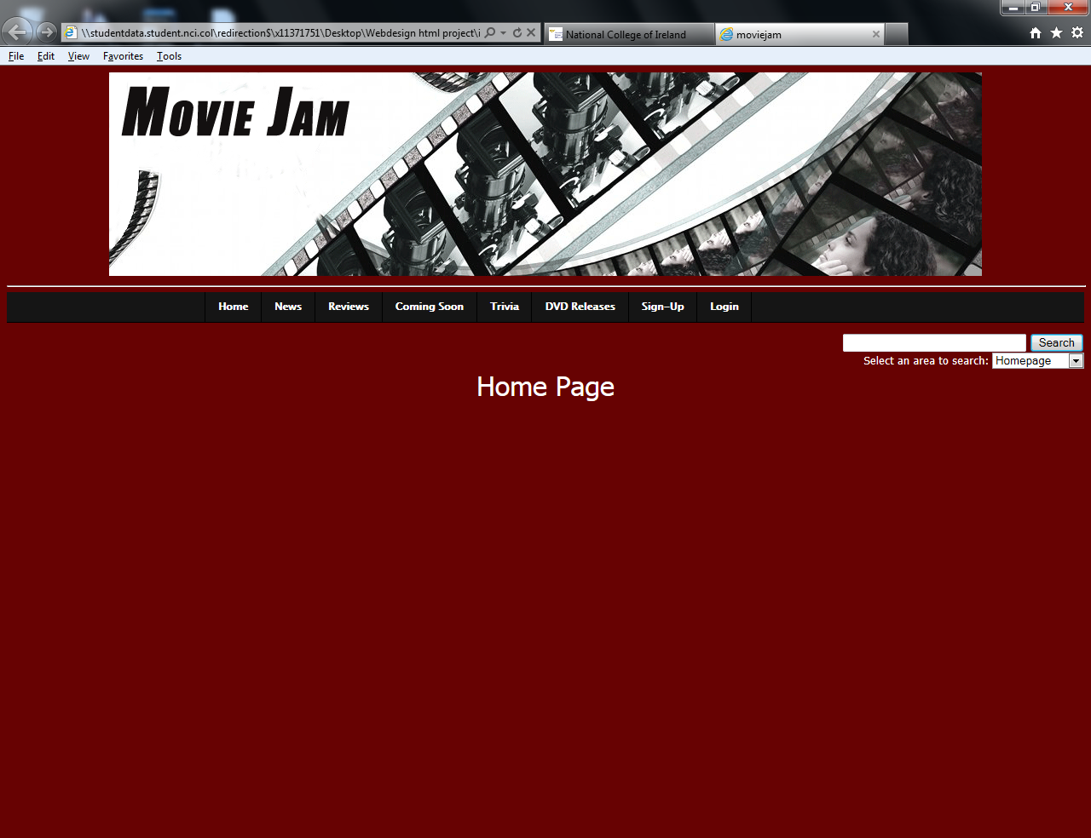
Template 4 Group Action Plan

Group Action Plan
List the tasks your group needs to complete
Assign tasks to each group member and agree on appropriate timelines

Action Plan:
No. | Action | Responsibility | Completed
1 | Plan out design of website | Group | Y
2 | Do css forms | Cian | Y
3 | Do all webpages(2 or 3 each) | Group | Y
4 | Do all JavaScript | Kevin | Y
5 | Do JavaScript for the trivia and coming soon and dvd releases | Alan | Y
6 | Make website header using Photoshop | Kevin | Y
7

8

9

10

Template 5 Individual Action Plan
Group member 1 should fill in this page


Individual Action Plan
Based on the task(s) assigned to you – record and synopsise your findings under the headings below.
Student Details: Student Name: kevin gleeson Student Number: x11371751

- What task(s) have you been assigned?
I am the record keeper so I have to do the workbook. I was also asked to do the log in and sign up pages and get them connected using JavaScript. I did not do the css forms for these pages as threat was cians role. I also done the about us page

- What information did you find out from your research?
How to make css forms connect into other webpages and also how to make confirm boxes for JavaScript.

- Explain how this information may be useful in the development of the website.
This will help me connect the sign up and log in page back to the homepage and also how I can put JavaScript into it
- What are you going to feedback to the group?
How I connected the sign up and login pages and what JavaScript I used

- Reference the information you have found.
www.w3schools.org
Individual Action Plan
Group Member 2 should fill in this page

Individual Action Plan
Based on the task(s) assigned to you – record and synopsise your findings under the headings below.
Student Details: Student Name: Cian Ellwood Student Number: x11526957

- What task(s) have you been assigned?
I have been assigned to create then CSS files and the index and reviews page for our website.

- What information did you find out from your research?
I found out from my research that by using CSS files I was able to align my images, style my text, create boxes for my forms and create a navigation bar by altering the list style in CSS. I also found out that CSS saved me writing large amounts of XHTML code as it could be repeated for different elements.

- Explain how this information may be useful in the development of the website.
This would be useful in developing a website as it would be helpful in styling my text and making the code writing process a lot easier. By styling the images in an external CSS file this would improve overall stability of the site across all different browsers. By utilising CSS files we managed to reduce the lines of code required to style each image, text and other website objects such as the navigation bar.

- What are you going to feedback to the group?
Im going to let the group know about my use of CSS and we plan on implementing it in all our pages also my navigation bar will be used for easy to use navigation across the site.
5. Reference the information you have found.
http://www.bleepingcomputer.com/forums/topic55647.html
http://www.imagecss.com
http://w3schools.com/
Individual Action Plan
Group Member 3 should fill in this page

Individual Action Plan
Based on the task(s) assigned to you – record and synopsise your findings under the headings below.
Student Details: Student Name Alan Fox Student Number x11103418

- What task(s) have you been assigned?
For this project I was asked to create the Dvd release section, the coming soon section and the Trivia section.

- What information did you find out from your research?
I learned how to use tables in a web site, how to make images as links to other web sites and how to create forms. I also researched the possibility of using java script to create the quiz.

- Explain how this information may be useful in the development of the website.
By using tables we can keep the site tidy, each row and data allows us to give a layout for our images and text. The form was useful in helping create the trivia section of the page as we could use radio buttons to create multiple choice questions.

- What are you going to feedback to the group?
Using javascript to create the trivia section would be very difficult to create and it’s very hard to get the code to validate properly.

- Reference the information you have found.
www.w3schools.com www.javascriptkit.com

Template 6 Reflection
Group Member 1 should fill in this page


REFLECTION
It is important for the group to reflect on how they arrived at the solution and the solution itself and to identify what could be improved on next time. (Students should complete about 500 words reflection)
Student Details: Student Name: Kevin Gleeson Student Number: x11371751
- Overall what has the experience been like working as part of a project team?
I found that working as part of a team really helped me improve my communication skills and helped learn more about designing a website. It also helped me learn about css which I was very weak on. I know now how to create css forms and how to apply them. When we were doing are project it was really easy to stay focused and interested in the project when you were in a group and had people supporting you. Being in a group helped me enjoy the project a lot more than if I was doing the project on my own. I really enjoyed working in a group also as I work better in groups then on my own as it helps get more ideas into the project.
- What have been the most positive parts?
I think that the most positive parts of doing the project was doing it on my group. I got on very well with my group and they thought me a lot about designing websites. Another very positive part of doing the project is that everyone in our group was willing to work at the best of their ability to produce a good website. I also really enjoyed the fact that in the end our website turned out exactly how we planned. We also didn’t have many problems with the code when we were writing it. The only real bit that was a negative was the validating. We done ours on strict validation so we had a lot of problems that we needed to correct and it took a long time to correct all the errors but in the end we got most of them corrected and got all the pages fully validated.
This also brought us into another positive that we could get things done quicker if we all work in a team and focus on the task at hand.
- What could be improved on next time?
I think that next time we are designing a website, we should plan it out in more detail. I also think we should add more moving objects into the project e.g. FLASH. This in my opinion would improve the look of the website and the feel of the website. I also would prefer to not do our web site in transitional form as we had to many problems with the strict type. I would also like to put more JavaScript into the website as it would make the website look more professional.
Template 6 Reflection
Group Member 2 should fill in this page

REFLECTION
It is important for the group to reflect on how they arrived at the solution and the solution itself and to identify what could be improved on next time. (Students should complete about 500 words reflection)
Student Details: Student Name: Cian Ellwood Student Number: x11526957

- Overall what has the experience been like working as part of a project team?
The experience of working in a project has been overall a very positive experience as we all shared our responsibilities equally and not one person was left with too much work. We also assisted each other in validating our pages. We regularly stayed back after college to work on our project and with this organisation we finished our project efficiently. My entire team was very willing to work on the site and we managed to use this dedication to create a very smooth, efficient site.
- What have been the most positive parts?
There were many positive parts of working with my team these included
- By sharing our responsibilities equally we were able to meet our deadline more realistically. By having one person take care of the CSS and another person take care of our JavaScript we were able to implement this more efficiently. This enabled us to achieve a more consistent look to our site earlier on.
- By assisting each other in validating our pages we were able to solve our errors on a larger scale then doing it individually for example if one error was consistent across all our pages then we were able to solve it by just solving one error. As a result we removed most, if not all of our validation errors quite easily
- By working after college on our site we were able to build a site that ran a lot better instead of a site that was hastily assembled. This after college effort helped us research more methods to improve our site and this lead to an improvement in our overall site design.
- We also constructively criticised each others work to help solve some of our design issues and this made our site look more professional and more accessible.

- What could be improved on next time?
- I believe that next time our effort could be improved by all of us working collectively on the JavaScript together as we had difficulties validating it at first.
- We should also contribute together on the pages in the future as that way we can work more efficiently as a team.

Aside from the aforementioned points I believe we worked rather well as a team.

Template 6 Reflection
Group Member 3 should fill in this page

REFLECTION
It is important for the group to reflect on how they arrived at the solution and the solution itself and to identify what could be improved on next time. (Students should complete about 500 words reflection)
Student Details: Student Name Alan Fox Student Number x11103418

- Overall what has the experience been like working as part of a project team?
Overall the experience of working as part of a project team was very enjoyable. The team I was with for this project worked really well together and everyone took to their roles very quickly with no hesitation. This contributed to the overall success of the project as each member knew exactly which section of the site they had to create and could start work as soon as they had their assigned tasks.

- What have been the most positive parts?
The most positive parts of working with this team has been that everyone co-operated fully with each other, we all came up with great ideas for the web site, and everyone listened to all the ideas put forward and nothing was dismissed without discussion first. Another positive aspect of working with this group was that if any member got stuck on a problem we all came up with ideas of how to help resolve the issue, no one was left to work alone and we could rely on each other for support throughout the project. The most positive aspect of the project was seeing all the individual pages linked together to create the site and seeing it fully operational.

- What could be improved on next time?

For our next project it would make it easier if we had a better understanding of javascript as we only started to learn about javascript towards the end of the assignment. By using javascript we could have made a slightly better quiz, as we would have been able to create code to allow users to see which questions they got right or wrong and could highlight the correct answer. It would also be good if we had a better understanding of how to read the errors when validating our code using the strict doctype as trying to find the errors took up a most of the project time.

Template 7 Bibliography

Referencing
You must reference any books, articles, or web pages which you used to create your web pages. This might include content for your site or resources on how to use a piece of JavaScript code. You must use the Harvard Referencing Style. There are resources on moodle to help you with this style.

www.w3schools.com
http://moodle.ncirl.ie/login/index.php
www.youtube.com
www.imdb.com
www.hmv.com
www.amazon.co.uk
www.cineworld.ie

Template 8 Peer Review


PEER REVIEW
When all group members contribute equally it makes sense for everyone to get the same result. However, if group members do not contribute evenly it is only fair that each group member receives the mark that truly reflects their contribution.

Each group member can earn a maximum of 10 marks for their contribution. Group members who made little or no contribution will receive fewer marks. The group must collectively rate each member’s contribution in the grid below by writing the member’s name in the box the group feels is most appropriate.
Main Contributor(s)    10 marks | Secondary Contributor(s)    7 marks | Minimal Contribution    0 marks | No Contribution    0 marks in Assignment
Cian Ellwood
Alan Fox
Kevin Gleeson

I Kevin Gleeson agree with the marks that have been awarded for my contribution to the assignment.
I Alan Fox agree with the marks that have been awarded for my contribution to the assignment.
I Cian Ellwood agree with the marks that have been awarded for my contribution to the assignment.

